* Power is supplied by connecting an AC adapter to the battery charging unit.
* An AVR USB Programmer is used to load the code onto the bot.

**Servo Pod Socket Connections:**

* The VCC (PIN 13/14) and GND (PIN 11/12) on the servo pod socket on the main board are connected to the corresponding VCC and GND pins of the BlueLink module.

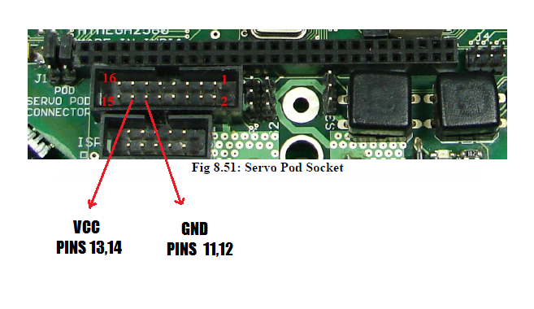

**Expansion Header on Micro-contoller board Connections:**

* The TXD3 (PIN 46) on the main board is connected to the RXD pin of the Bluelink module.
* The RXD3 (PIN 45) on the main board is connected to the TXD pin of the Bluelink module.
* These connection are made to receive transmit messages from the bluetooth module to the micro-controller.

